La Roche-Posay

Requirement Specifications

Document Approval

|  |  |  |  |
| --- | --- | --- | --- |
| **BaselineVersion** | **Approve Date** | **Reviewer** | **Approver** |
| 1.0 | 05-03-2012 | Arnaud Sitbon, Linh Nguyen | Arnaud approves on the client requirements and BA copy and paste the contents from client reqs into reqs spec template of company. |
| 1.1 | 10-03-2012 | Tristan | Approve change request for applying effect step. |

Document Revision History

|  |  |  |  |
| --- | --- | --- | --- |
| **Version** | **Date** | **Author** | **Change Description** |
| 0.1 | 03-03-2012 | Linh Nguyen | Update requirements base on client requirement |
| 1.0 | 09-03-2012 | Linh Nguyen | Update change request of applying effects step. |

Table of Contents

I. Introduction 4

II. Master Use Case & Functional Diagram 4

1. Master Use Case Diagram 4

2. Master Functional Diagram 4

III. Functional Requirements 4

1. Mobile Application 4

IV. Non Functional Requirements 15

1. Mobile version 15

2. International app 15

V. Risk and Communication Plan 15

3. Risk and Mitigation Plan 15

4. Communication Plan 15

VI. Glossary 16

# Introduction

*This document describes the whole requirements of project – Laroche Posay*

# Functional Requirements

## Mobile Application

### *Descriptions*

Describe the requirements of mobile application. This app supports 2 mobile OS: Android and iOS. For Android, the phase 1 will only cover only 480 x 800 resolution.

### *Main flow*

1. Touch on the app icon to open the app

2. The splash screen appears until the whole system loaded successfully, then jump to warning screen

3. User clicks con Agree to go to Home page of app. Cancel to close the app

4. Go steps by steps to play the taken photo. If there is the added effect, user is not able to back the previous step.

5. Sharing to Facebook, Mail, Download to the gallery on Mobile will finish the flow.

6. Button at last screen to allow user back to the app.

### *Related Use Cases*

### Home screen

### Descriptions

Describe the steps to take the photo on mobile app

### Related screens

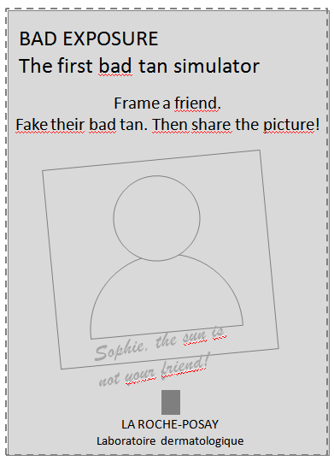

Figure 1: The splash green

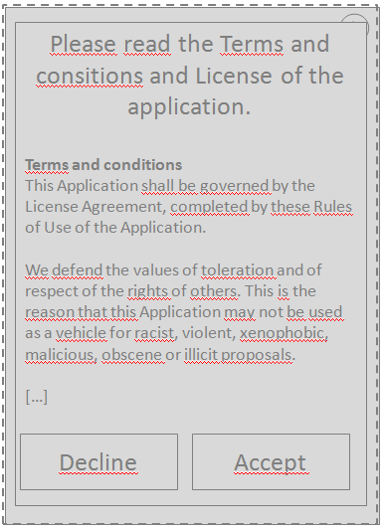

Figure 2: Warning Screen

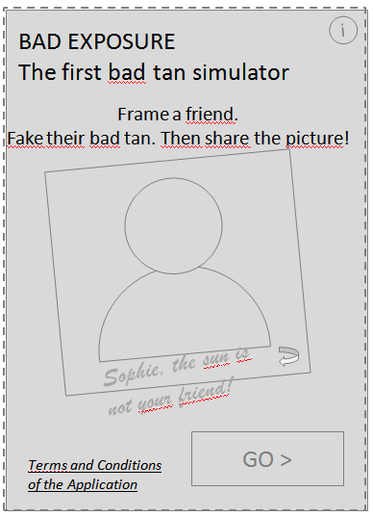

Figure 3: Home screen

### Constraints & Business rules

1. Splash screen – figure 1 displayed when loading the application. No available action

The figure 2 will be displayed automatically once all the actions in application are ready to use.

2. This popin appears at first launch of the app

> If user clicks Accept the popin closes and the user can use the application.

> If user clicks Decline the app closes.

3. Example picture on home screen changes to show 3 different effects. (Figure 3)

> When touching the picture (or arrow icon) the image rotates to show the back.

> The i icon in the corner opens a popin page with credits and legal info

### Step 2 – Photo taken/ Upload

### Descriptions

Describe the steps of taking photo or get from the library

### Related screens

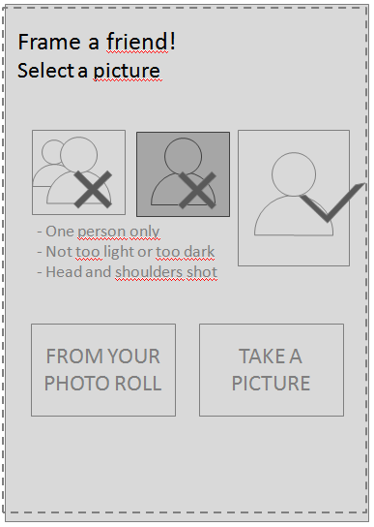

Figure 1: Instruction page

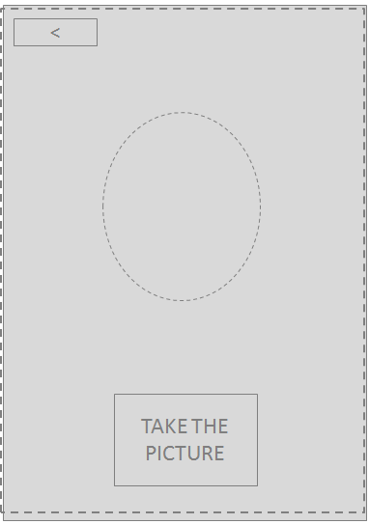

Figure 2: Take Photo

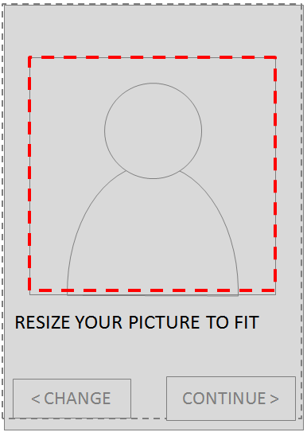

Figure 3: Frame after taking photo

### Constraints & Business rules

1. There is the general content to give examples of bad and good pictures.

2. The user can choose a picture from the photo roll or take one with the camera.

3. When choosing Camera, the camera is activated and the expected face area is shown with

a dotted line. The user can cancel and go back or take the picture. (Figure 2)

4. Once the photo is taken or chosen the user must place it in the square to crop it to a

square format. (Figure 3)

> Actions are:

+ Move (1 finger)

+ Zoom in/out (with pinch and zoom)

+ Pinch: Multi-touch gesture

### Step 3 – Tan zone apply

### Descriptions

Describe the steps of applying the tan zone

### Related screens

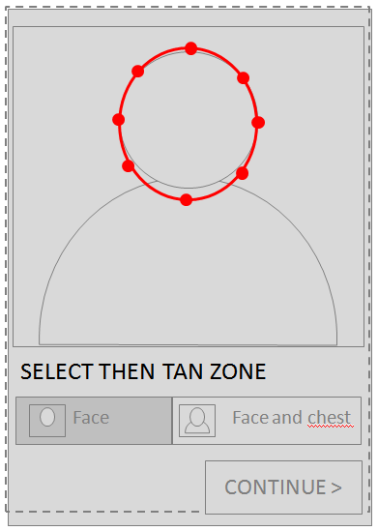

Figure 1: Default tan zone of face

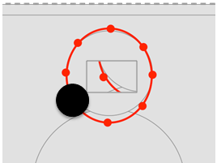

Figure 2: Zoom the zone (without the line in Zoom box, only dot support)

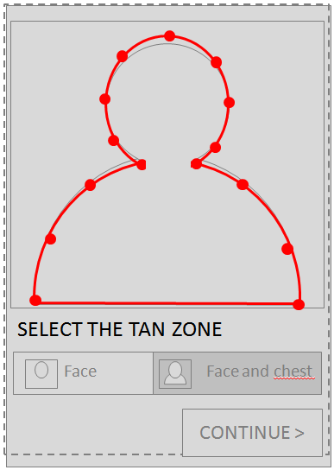

Figure 3: Tan zone of Face and Chest by default

### Constraints & Business rules

1. The user must define the tan zone. Default selected is Face only. The user can edit the

shape by moving the dots on the line. When touching the dot, a small window appears next to

the finger to show the details under. It allows fine edition of the shape. (Figure 1 & Figure 2)

2. Case Face and chest (the default shape is different). The 2 dots at the bottom can be moved left or right, but cannot be moved up. They must remain on the bottom line.

### Step 3 – Place eyes and mouth

### Descriptions

Describe the steps of placing the eyes and mouth

### Related screens

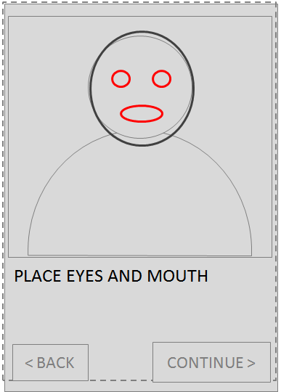

Figure 1: Default eyes and mouth points

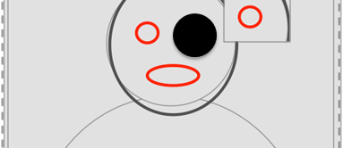

Figure 2: Zoom box

### Constraints & Business rules

1. The user places marks for eyes and mouth. These marks are used to substract eyes and mouth from the tan zone (defined in 2). This will allow to keep the eyes and mouth/teeth with natural color. The user validates with Continue. Back allows to get back to precedent step.

2. We use the same system for a fine placement : display of the zone under the finger next to it.

### Step 4 – Tan color apply

### Descriptions

Describe the steps of applying the tan color

### Related screens

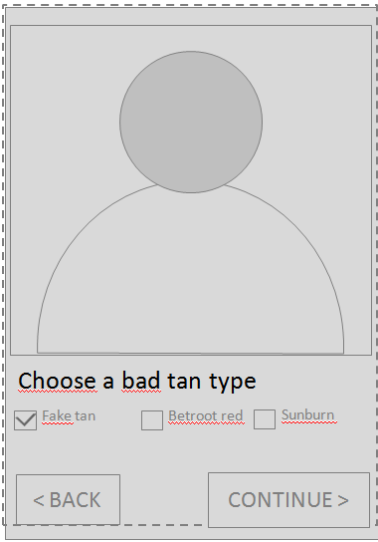

### Constraints & Business rules

Tan color : 3 colors available, first one is selected by default. Only one can be selected.

### Step 5 – Effect apply

### Descriptions

Describe the steps of applying the effect

### Related screens

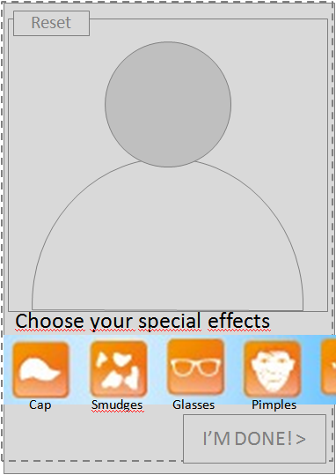

### Constraints & Business rules

1. Effects : the user can apply a choice of effects. Effects can be combined. When clicking an effect it appears on the picture, and can be edited. No other effect is clickable when in edit mode.

2. When an effect is clicked you enter edit mode. Other effects are not available. By default the effect shape is displayed on the picture. You can edit the shape:

> Resize (with pinch and zoom)

> Move (1 finger)

> Rotate (2 fingers rotation)

3. The user can validate with Ok or remove effect with Remove.

4. After validating an effect the icon has a different color. It indicates that this effect is applied.

You can edit or remove an effect by clicking again on it and enter edit mode. If you remove the effect the icon gets its original color.

5. You can use each effect only once (only one pair of glasses, …).

### Step 6 – Sharing

### Descriptions

Describe the steps of sharing the final product

### Related screens

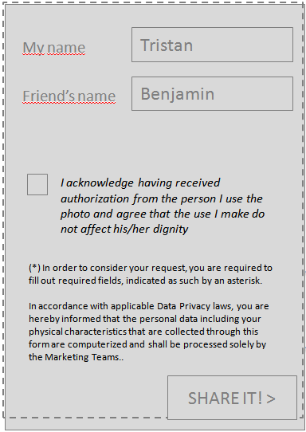

Figure 1: Enter friend’s name

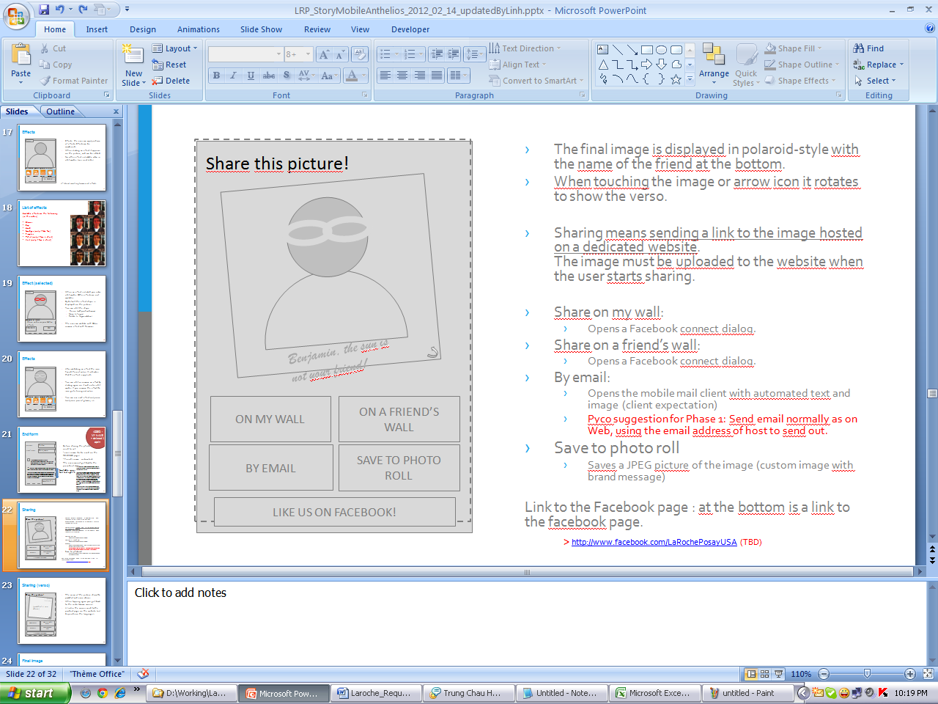

Figure 2: Sharing screen

### Constraints & Business rules

1. The final image is displayed in polaroid-style with the name of the friend at the bottom. When touching the image or arrow icon it rotates to show the verso. Sharing means sending a link to the image hosted on a dedicated website. The image must be uploaded to the website when the user starts sharing.

2. **Share on my wall:**

> Opens a Facebook connect dialog.

> Save to photo roll

Saves a JPEG picture of the image (custom image with brand message)

**3. Link to the Facebook page : at the bottom is a link to the facebook page.**

> http://www.facebook.com/LaRochePosayUSA (TBD)

# Non Functional Requirements

**Mobile version:**

iPhone version (compatibility iOs 4+)

Android version (compatibility 2.2+)

**International app:**

One version of the app for all countries

Integration of new languages with updates.

# BA Plan

## Communication Plan

*Refer to the BA plan of this project: Z:\Projects\EU\BETC\Anthelios\Documents\Review\Requirements\585-Business Analysis Plan-Laroche Posay-Anthelios-v1.0.xlsx*

*--- End of document ---*